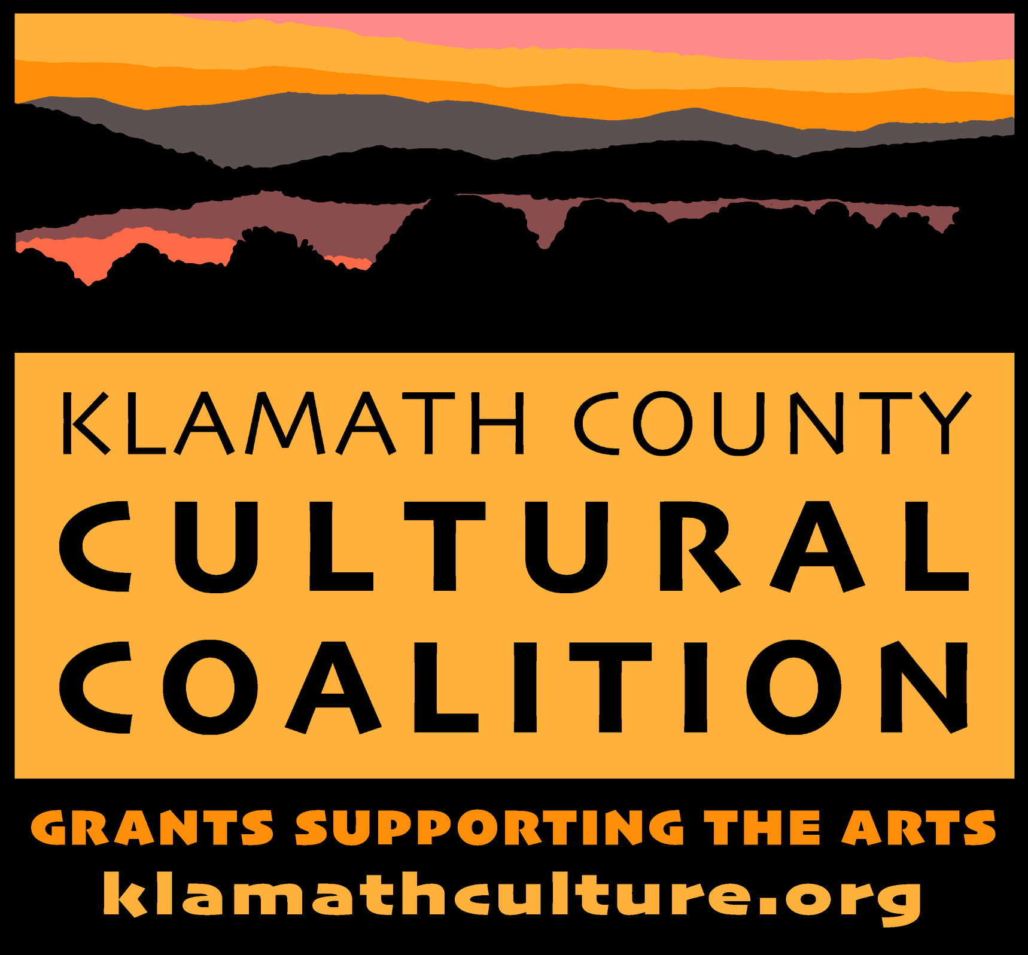

Klamath County Cultural Coalition
2023 Grant Guideline/Information and Application Form
Deadline for application submission: November 17, 2023

During times of Covid, all grant projects must adhere to the current state guidelines for vaccines and mask requirements.
Please refer to the Klamath County Cultural Coalition website for instructions on how to submit your application and tax information.

No application will be reviewed by our board unless all questions are answered.

Culture includes all pursuits and activities associated with life in Klamath County as it relates to the performing arts, visual arts, and historical and heritage preservation.

Please become familiar with the grant application document before completing it. Grant awards will be in amounts up to $2000 per project. Be especially mindful of the number of people served in the community and the organizations who provide funds in support of your project. In addition, be cognizant of the impact your project will have on the local community. Please know that a project that is repeated in three consecutive years will receive significantly less grant funding.

A final report is required by the state and is due 30 days after project completion. Your organization’s final report is due on or before December 31, 2024. The final report form is on the Klamath County Cultural Coalition website.

If for some reason you cannot complete your funded project, please contact Rich Bergstrom (541-205-2800) as soon as possible.

Directions for completing grant

Page 1: Provide the appropriate contact information. You must complete Tax Status information. Please check Klamath County Cultural Coalition website for instructions on how to complete and submit your W-9 form.

Page 2: Provide information about your project, including an estimate of number of people served. Briefly list sources of financial and other support from the local community and total project cost. Provide the amount you are requesting from the coalition.

Page 3: Include a brief summary of your organization’s activities. Provide a project description, materials needed, skills learned and how the funds will be used.
Page 1

Grant Application
Oregon Cultural Trust
Klamath County Cultural Coalition

Organization information:

Name of Organization: ___________________________________________________

Contact Representative and Position: _______________________________________

Mailing address (include Zip Code): _________________________________________

Phone number: ________________________

Email: ________________________

Tax Status Information

Legal name of organization:

Tax Status (Check appropriate status)
____ 501(c)(3) (Attach copy of approval from Internal Revenue Service)
____ 170(c)(1) Government unit, such as school or library

_W-9 Form, please refer to the Klamath County Cultural Coalition website for instructions on how to complete and submit your W-9 form.

Tax ID/Employer Number:_____________________

Tax Registration Date: __________________

Page 2

GRANT APPLICATION (cont.)

Project Information

Number of people this project will serve:_______________________

Project Type (Please check category or categories that best describe the focus of your project:)
____ Education
____ Visual Arts
____ Performing Arts
____ Heritage
____ Humanities
____ Other

Proposed project START date:_________________

Proposed project COMPLETION date:_______________

Total project cost:________________

Amount raised to date for this project, including commitment of your organization's funds:

Did the project receive additional funds from the local community? Please list.

Total amount requested from the Coalition:______________________________

Primary Activities of Organization:

Page 3

Proposed Project:
Describe the project. What has your organization done to prepare for this proposed project? How will the funds be used?

The deadline for submission is November 17, 2023. Allow KCCC Grant committee 30 days after submission deadline to evaluate grant application and issue grant awards letters. Grant checks will be awarded at a later date.

You must include the name “Oregon Cultural Trust” or “Klamath County Cultural Coalition” in all your group’s project publicity (including all print and visual media.) Failure to include us in your press release will jeopardize your future funding.
Applications and W-9 form are to be sent via email to Rich Bergstrom at richb1943@live.com..
If for some reason you cannot complete your funded project, please contact Rich Bergstrom (541-205-2800) as soon as possible.
Thanks for your participation, Rich Bergstrom and the KCCC Board

